Andy Rigby coming to Tassie in January 2022
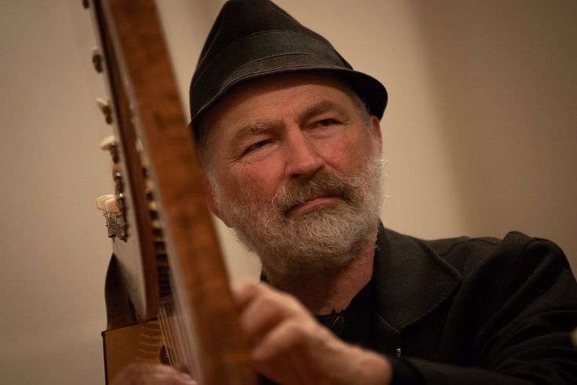
For those of you who don’t know Andy, he is a Central Victorian Harpist and Harp-maker and is a well-known identity in the Australian folk scene. A multi-instrumentalist, Andy has performed and has been engaged as a workshop teacher at leading festivals around Australia as well as running his own harp camp, Harpers Bizarre. He performs most of the folk traditions involving the harp, and also makes and plays flutes, whistles and marimbas. Andy is one of Australia’s leading designers, makers, players, and teachers of the harp in both its Celtic and Latin American form. He will be running a workshop, open to both harp society members and non-members, and will cater for multiple skill levels.
Bookings are essential.

